QT Design Studio 制作登录界面

1 Login UI: Components
Illustrates how to use wizard templates to create a simple UI that contains a text label, images, and push buttons.
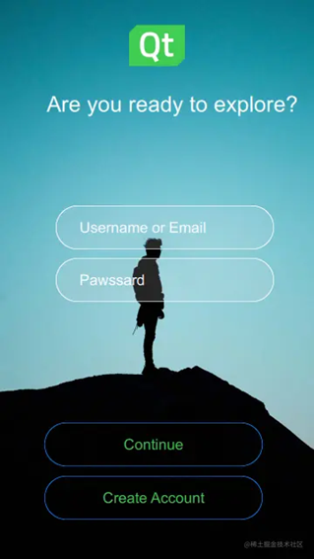
Login UI: Components is the first of the Qt Design Studio Login UI tutorials, which build on each other to illustrate how to create a simple UI with some basic UI components, such as pages, buttons, and entry fields.
This tutorial describes how to use the Qt Design Studio wizard templates to create a project and a button UI control, and how to modify the files generated by the wizard templates to design a UI.
You can download the completed project from here.

Creating the UI project
For the purposes of this tutorial, use the empty wizard template to create the UI project. For other purposes, use one of the wizard templates for creating UIs optimized for mobile platforms or launcher applications. For more information see Creating projects.
To create a project using the empty wizard template:
- Select File > New Project.
- In the Presets tab, select General > Empty (1).
- In the Details tab:
  - Enter Loginui1 as the name (2) for the project. Keep in mind that projects cannot be easily renamed later.
  - Select the path (3) for the project files. You can move project folders later.
  - Set Width to 720 and Height to 1280 (4). You can change the screen size later in Properties.
- Select Create (5) to create the project.
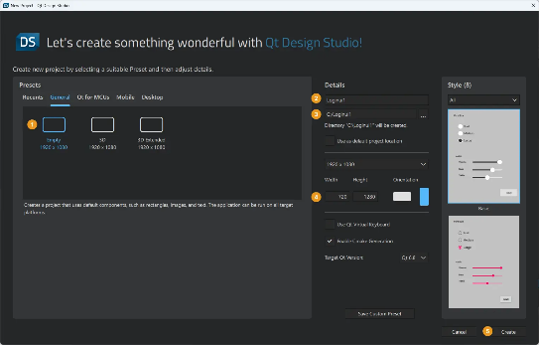
Your project should now look something like this in the Projects view:
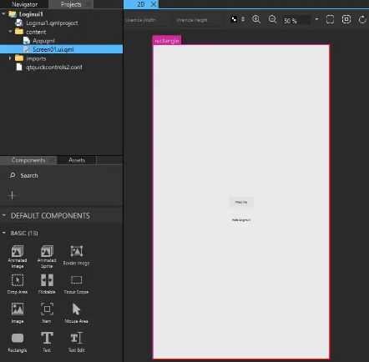
The wizard constructs the Screen01 component using a rectangle component as the background, a Button, and a Text component that displays some text.
Note: The visibility of views depends on the selection of views on the selected workspace, so your Qt Design Studio might look somewhat different from the image above. To open and close views, select View > Views. For more information about arranging the Qt Design Studio workspace, see Workspaces.
Remove the button and the text component from the UI to have a clean workspace. Add button and text components later in this tutorial as instructed.
To remove the button, select it and select Backspace. Repeat for the text component.
Next, edit the values of the properties of the component instances to create the main page of the UI.

Creating the main page
After creating the new project and setting up a clean workspace, you are now ready to create the main page of your UI. First, download a logo, a background image, and a custom font and import them to Qt Design Studio as assets. Then, use these assets to add a background image, a logo, and a tag line to your main page.
Download the logo and the background image from here:
- qt_logo_green_128x128px.png
- Background image (adventurePage.jpg)
Photo by Benjamin DeYoung on Unsplash.
Download the Titillium Web ExtraLight font from here or use Arial as a substitute.
To add the assets:
- Select Assets > (If you can't see the Assets view, select View > Views > Assets.)
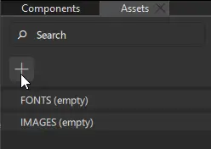
- Select the asset files, and then select Open.
- In the Add Resources dialog, select the location for saving the files.
- Select OK.
Alternatively, drag the asset files from the file browser to the Fonts or Images tab in the Assets view.
To preview the changes that you make, select the run dropdown menu from the top toolbar, and then select Live Preview, or select Alt+P.
Note: If you can't see the changes that you make in the 2D view, select on the 2D view toolbar to refresh the 2D view.
The Screen01.ui.qml file, that the wizard template created for you, should be open. If it is not, you can double-click it in the Projects view to open it.
To modify the Screen01 component in the 2D view:
- Drag the background image (1) from Assets to the 2D view (2). Use the guidelines (3) to drag the background image so that it covers the whole 2D view.
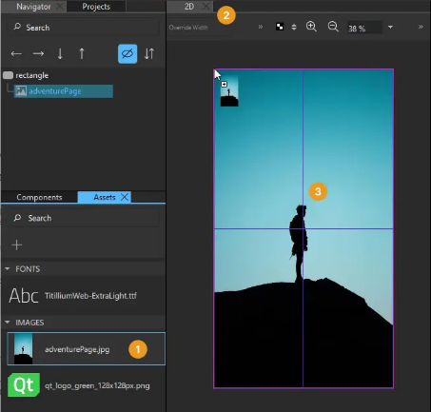
Adding an image to the 2D view creates an Image component to your project, which appears under rectangle in Navigator. The component is created with the path to the image file set as the value of Properties > Image > Source.
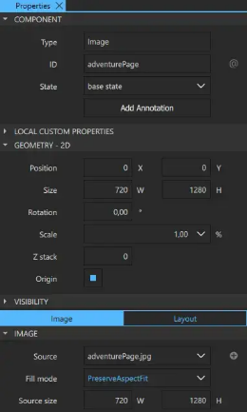
- Drag the Qt logo from Assets to the background image in the 2D view. Use the guidelines to drag the logo precisely to the top horizontal center of the background image.
- Drag a Text component from Components > Default Components > Basic below the logo image in the 2D view.
- Select the Text component to edit the text properties in the Properties view:
- In Component > ID, enter the ID tagLine.
- In Character > Text, enter the tag line: Are you ready to explore?.
- In Character > Font, select Titillium Web.
- In Style name, enter ExtraLight.
- In Character > Size, set font size of the tag line to 50 px.
- In Character > Text color, set the text color to white (#ffffff).
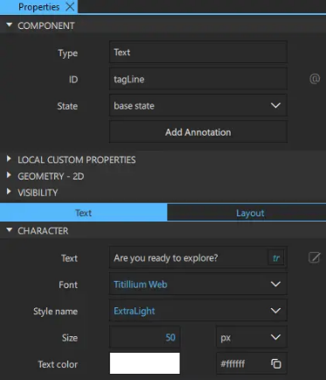
- Drag the tagline to the horizontal center below the logo using the guidelines.
- Select File > Save or Ctrl+S to save your changes.

Your UI should now look something like this in the 2D view and Live Preview:
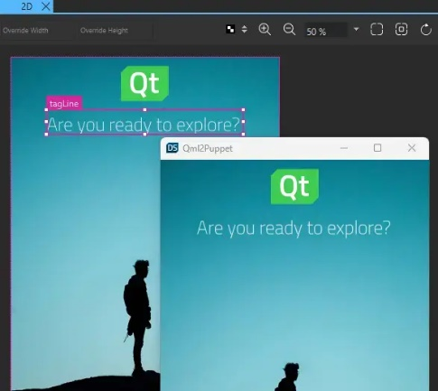
Resize the Live Preview window to see the whole screen.
You are now ready to add push buttons to your UI.

Creating a Push Button
Next, you use another wizard template to create a push button and add it to the UI. The wizard template creates a reusable button component that appears in Components > My Components. You can drag it to the 2D view and modify its properties in the Properties view to change its appearance and functionality.
If you cannot use the wizard template nor the preset button controls to create the kind of push button that you want, you can create your button from scratch using default components. For more information, see Creating buttons and Creating scalable buttons and borders.
To create a push button by using the wizard template:
Select File > New File > Qt Quick Controls > Custom Button > Choose.
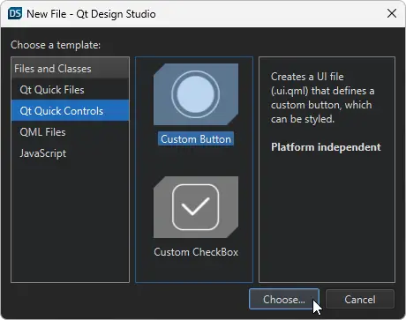
In the Component name field, enter a name for your button component: EntryField.
Select Finish (or Done on macOS) to create the button UI file, EntryField.ui.qml.
Your button should now look something like this:
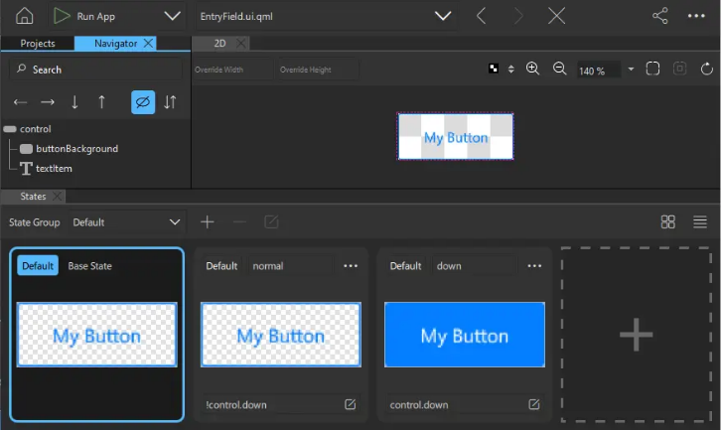
Next, change the appearance of the EntryField component by modifying its properties.

Styling the button
To style your new button, edit the properties of the EntryField component. To make the changes apply to all the EntryField instances, you must make them in the EntryField.ui.qml file.
The Custom Button wizard template adds a normal state and a down state to change the button background and the text color when the button is clicked. Now, change the colors in all states. When you make changes to the button in the Base State, they are automatically applied to the other states. However, the property values that have been explicitly changed in the normal or down state are not changed automatically, and you have to either reset them to the Base State or set them separately in that state.
To change the button property values:
- Select control in Navigator to display its properties in Properties.
- In Geometry - 2D > Size, set button width (W) to 500 and height (H) to 100, to match the width of the tag line.
- In the Control section, clear the Hover checkbox because you don't want the hover effect for the button.
- Select buttonBackground in Navigator to display its properties in Properties.
- In Properties > Rectangle, set:
- Fill color to transparent light gray (#28e7e7e7). You can also use the color picker to set the color.
- Border color to white (#ffffff).
- Radius to 50 to give the button rounded corners.
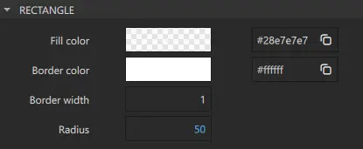
- Select textItem in Navigator to display its properties in Properties.
- In Properties > Character, set:
- Font to Titillium Web
- Style name to ExtraLight.
- Size to 34 px.
- Text color to white (#ffffff).
- Alignment H to left to align the text horizontally to the left.
- Alignment V to center to align the text vertically to the center.
- In Properties > Padding > Horizontal > Left, set the padding in the field between background border and text to 50.
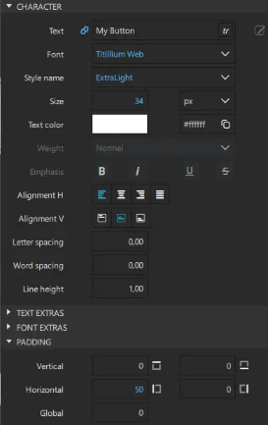
- In the States view, select the normal state and repeat the changes in the background color and text properties, as necessary. Repeat for the down state.
- Select File > Save or select Ctrl+S to save your changes.

Your button should now look something like this:
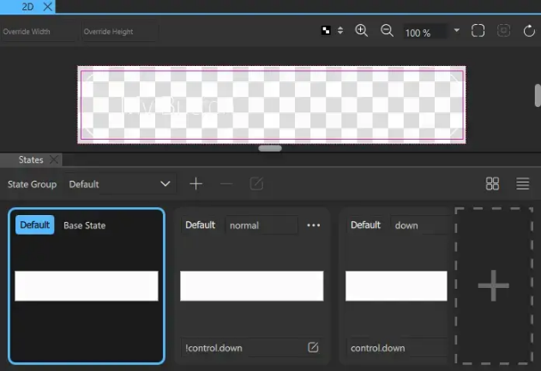
Note: Do not edit the value of Text in the Character property because this breaks the connection, and prevents any later changes in Button Content > Text.
Next, add two instances of the EntryField component to the Screen01 component and modify their properties.

Adding entry fields to the UI
To add two entry fields to the UI and modify their properties:
- Double-click Screen01.ui.qml in Projects to open it in the 2D view.
- Drag two EntryField components (1) from Components > My Components below the tagline in the 2D view. Use the guidelines (2) to align the buttons directly below the tagline.
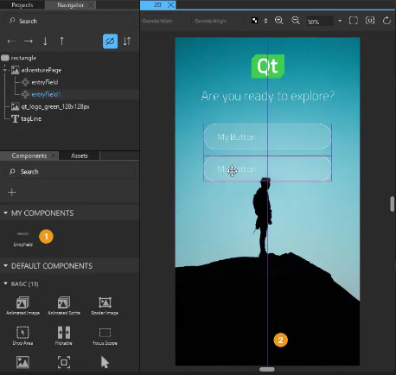
- Select the first EntryField button in the 2D view or Navigator to modify it in Properties.
  - In Component > ID, enter username.
  - In Button Content > Text, enter Username or Email and select tr to mark the text translatable.
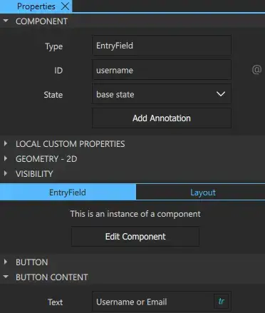
- Select the second EntryField, and change its ID to password and text to Password. Again, mark the text translatable.
- Select File > Save or select Ctrl+S to save your changes.
Next, create another button that you can use in your UI.

Creating another button
You need to create another button for your UI. This time, you want to center-align the text of the buttons and use brighter colors for them, so you create a second button component as instructed in Creating a Push Button. This time you call it PushButton.
To make the changes apply to all the PushButton instances, you must make them in the PushButton.ui.qml file.
To change the button property values:
- Select control in Navigator to display its properties in Properties.
- In Geometry - 2D > Size, set button width (W) to 500 and height (H) to 100.
- In the Control section, clear the Hover checkbox because you don't want the hover effect for the button.
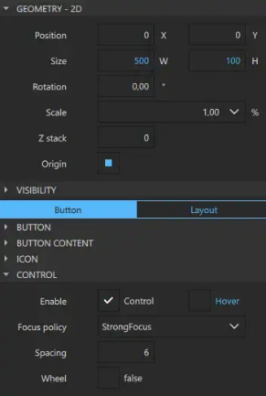
- Select buttonBackground in Navigator to display its properties in Properties.
- In Properties > Rectangle, set:
  - Border color to the green used in the logo (#41cd52).
  - Radius to 50 to give the button rounded corners.
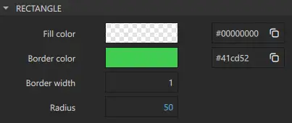
- Select textItem in Navigator to display its properties in Properties.
- In Properties > Character, set:
- Font to Titillium Web
- Style name to ExtraLight..
- Size to 34 px.
- Text color to (#41cd52).
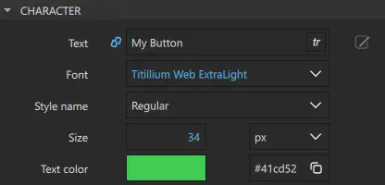
- In the States view, select the normal state and repeat the changes, as necessary.
- Repeat for the down state. However, in Rectangle > Fill color, set the color to green (#41cd52) to turn the button background green when the button is pressed down. Also, in Text > Character > Text color, keep the text color as white (#ffffff).
- Select File > Save or select Ctrl+S to save your changes.
Your button should now look something like this in Base State:
Next, add two buttons to the UI as s the final step in this tutorial.
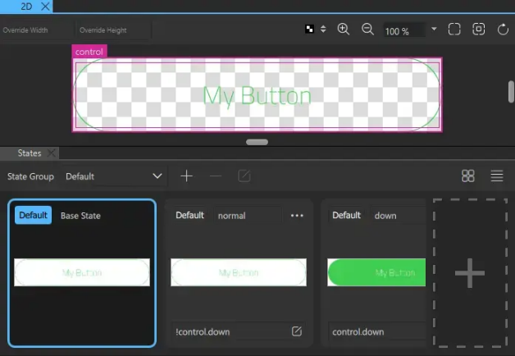

Adding push buttons to the UI
To add two buttons to the UI and modify their properties:
- Select the file dropdown menu (1) from the top toolbar, and then select Screen01.ui.qml to open it in the 2D view.
- Drag two PushButton components (2) from Components > My Components to the bottom of the background image in the 2D view. Use the guidelines (3) to align the push buttons horizontally with the entry fields.
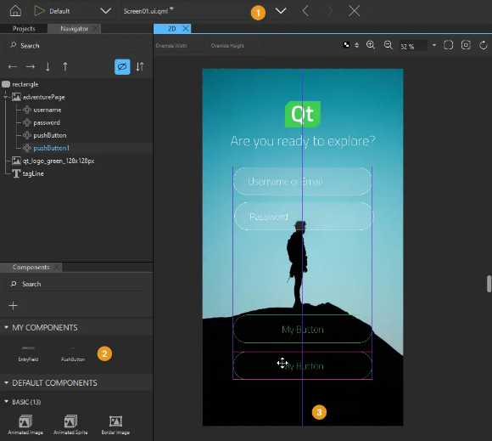
- Select the first PushButton in Navigator or the 2D view to modify it in Properties.
- In Component > ID, enter login.
- In Button Content > Text, enter Continue and select tr to mark the text translatable.
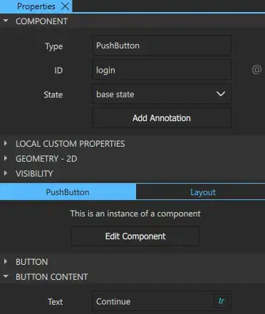
- Select the second PushButton and change its ID to createAccount and text label to Create Account. Again, mark the text translatable.
- Select File > Save or select Ctrl+S to save your changes.
The first iteration of your UI is now ready and should now look something like this in the 2D view and Live Preview:
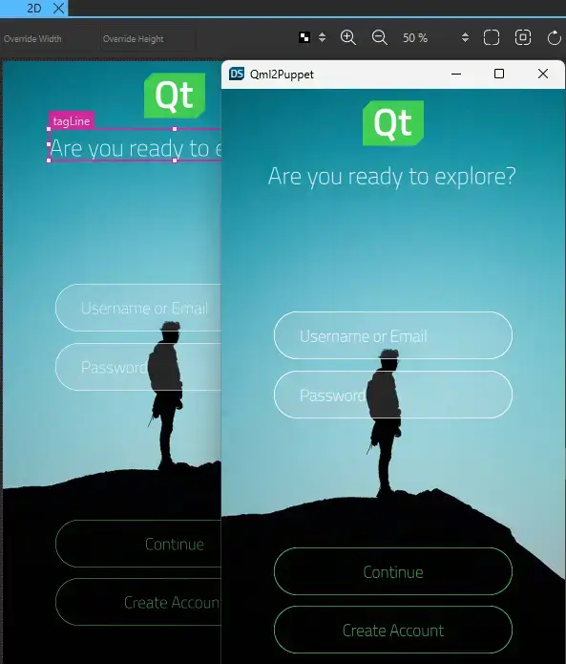

Next steps
To learn how to add more UI controls and position them on the page using anchors and layouts so that the UI is scalable, see the next tutorial in the series, Login UI: Positioning.

2 Login UI: Positioning
Illustrates how to position UI components on pages using anchors and positioners.
Login UI: Positioning is the second of the Qt Design Studio Login UI tutorials, which build on each other to illustrate how to create a simple UI with some basic UI components, such as pages, buttons, and entry fields.
This tutorial describes how to position the UI components on pages to create a scalable UI. Use anchors and positioners to ensure that the layout is responsive and all the UI components stay in their proper places when you resize the UI on the desktop or on devices with different screen sizes.
The starting point for this tutorial is the completed Login UI: Components project. You can download the project here.
Additionally, you can download the completed project of this tutorial here.

Changing the component hierarchy
You can only anchor components to their parent and sibling components. First, to make the entry fields and the buttons sibling components to other page elements, drag them from adventurePage to rectangle in the Navigator view (press and hold the Shift or Ctrl key for multiple selection).
Next, anchor the static elements to the UI.
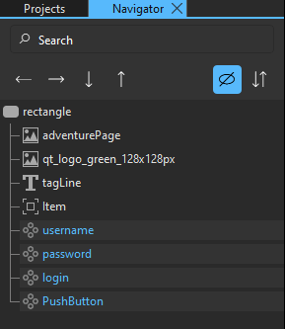

Anchoring UI components
Anchor the static page elements, meaning the background image (adventurePage), the logo (qt_logo_green_128x128px), and the tag line (tagLine), to the page.
To preview the changes that you make, select the run dropdown menu from the top toolbar, and then select Live Preview, or select Alt+P.
To edit the main page, first select Screen01.ui.qml in the Projects view.
Then, to anchor the components in your UI:
- Select adventurePage in Navigator to display its properties in the Properties view.
- In Properties > Layout, select the anchor button to anchor adventurePage to its parent in the Target field. This attaches the background image to the rectangle on all sides.
Note: Selecting the anchor button should automatically select the four buttons on the left side of it. If it doesn't, select on the 2D view toolbar to refresh the 2D view.

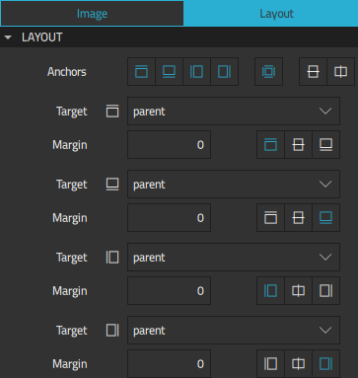
- Select qt_logo_green_128x128px in Navigator.
- In Properties > Layout, set:
  - Anchors to and .
  - Target to parent to anchor the logo to its parent.
  - Margin to 40, and select to anchor the logo to the top of the target.
This attaches the logo to the rectangle at the top while keeping its horizontal center aligned with that of the rectangle.
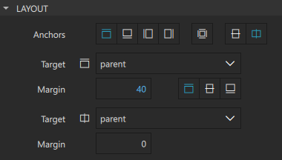
- Select tagLine in Navigator.
- In Properties > Layout, set:
- Anchors to and .
- Target to qt_logo_green_128x128px to anchor the tag line to the logo.
- Margin to 40, and select to anchor the tag line to the bottom of the target.
- This attaches the tag line to the bottom of the logo while keeping its horizontal center aligned with that of the rectangle.
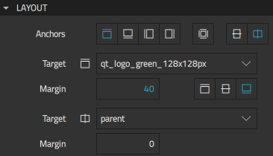
Note: You can anchor component instances to their parent and sibling components. If a component is not listed in the Target field dropdown menu, check that the component is located in the correct place in the component hierarchy in Navigator. For more information, see Arranging components.
Select File > Save or select Ctrl+S to save your changes.
Your page should now look something like this in the 2D view and Live Preview:
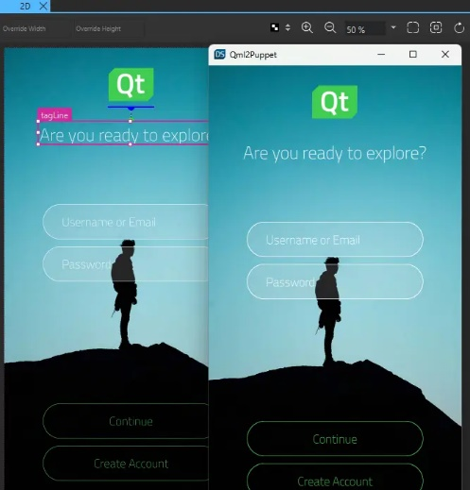

Using column positioners
Next, position the entry fields and buttons in columns to learn another method of positioning components. Then, anchor the columns to the page, so that their positions adapt to any screen size changes.
To position the fields and buttons as columns:
- Select username and password in Navigator (press and hold the Shift or Ctrl key for multiple selection), and right-click either of them to open a context menu.
- Select Positioner > Column Positioner to position the fields on top of each other in the 2D view.
- Select the column in Navigator and change its ID to fields in Properties.
- In Column > Spacing, set the spacing between the fields to 20.
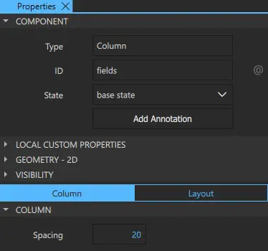
- Select login and createAccount, and then select Positioner > Column Positioner to position them in a column.
- Select the new column, change its ID to buttons, and set the spacing between the buttons to 20, as above.
Now, anchor the field and button columns to the page:
- Select fields in Navigator.
- In Properties > Layout, set:
  - Anchors to and .
  - Target to tagLine to anchor the entry fields to the tag line.
  - Margin to 170 and select to anchor the entry fields to the bottom of the target.
- This attaches the entry fields to the bottom of the tag line while keeping its horizontal center aligned with that of the rectangle.
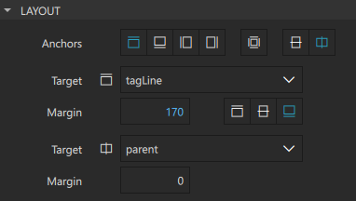
- Select buttons in Navigator.
- In Properties > Layout, set:
- Anchors to and .
- Target to parent to anchor the entry fields to the rectangle.
- Margin to 50, and select to anchor the entry fields to the bottom of the target.
This attaches the buttons to the bottom of the rectangle while keeping its horizontal center aligned with that of the rectangle.
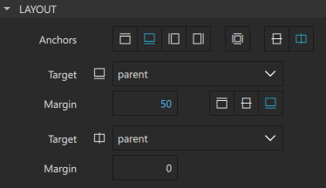
- Select File > Save or select Ctrl+S to save your changes.
The second iteration of your UI is now ready and should look something like this in the 2D view and Live Preview:
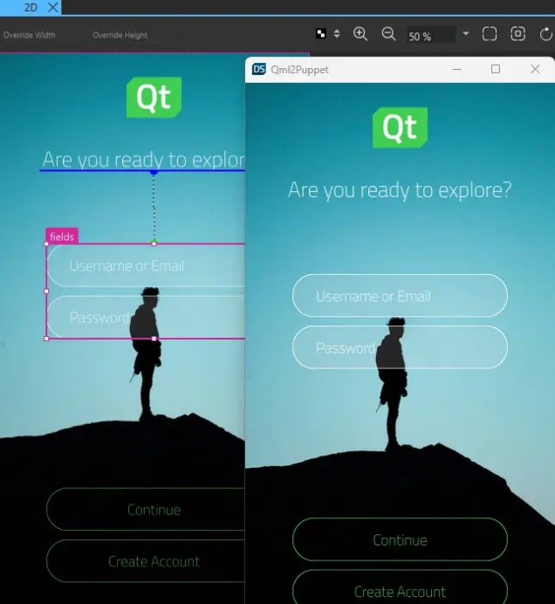

Next steps
To learn how to add a second page and move to it from the main page, see the next tutorial in the series, Login UI: States.

3 Login UI: States
Illustrates how to use states to create a second UI page.
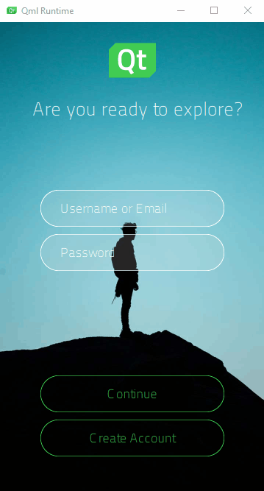
Login UI: States is the third of the Qt Design Studio Login UI tutorials, which build on each other to illustrate how to create a simple UI with some basic UI components, such as pages, buttons, and entry fields.
This tutorial describes how to use states to add a second page to the UI. On the first page, users can enter a username and password to log in. On the second page, they can register as users if they do not already have an account.
Because the complete second page contains most of the same UI components as the login page, use states to show and hide UI components as necessary when a user selects the Create Account button.
The starting point for this tutorial is the completed Login UI: Positioning project. You can download the project here.
Additionally, you can download the completed project of this tutorial here.

Adding UI components
Add another entry field for verifying the password that the user enters to create an account. You are already familiar with the tasks in this section from the previous Login UI tutorials.
To preview the changes that you make, select the run dropdown menu from the top toolbar, and then select Live Preview, or select Alt+P.
To add the entry field needed on the second page to the Screen01 component:
- Double-click Screen01.ui.qml in Projects to open it in the 2D view.
- Drag an EntryField component from Components > My Components to fields in Navigator.
- Select the EntryField in Navigator to modify its ID and text in Properties.
- In Component > ID, enter repeatPassword.
- In EntryField > Button Content > Text, enter Repeat Password and select tr to mark the text translatable.
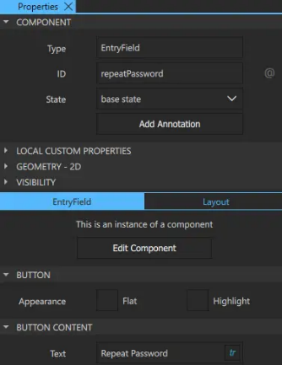
Select File > Save or select Ctrl+S to save your changes.
Screen01 should now look something like this in the 2D view:
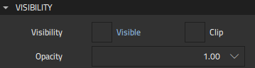
Next, add states for the login page and the account creation page, where you use the visibility property to hide the Repeat Password field on the login page and the Create Account button on the account creation page.

Using states to simulate page changes
Add states to the UI to show and hide UI components in the 2D view, depending on the current page:
- In the States view, select .
- Enter login as the state name.
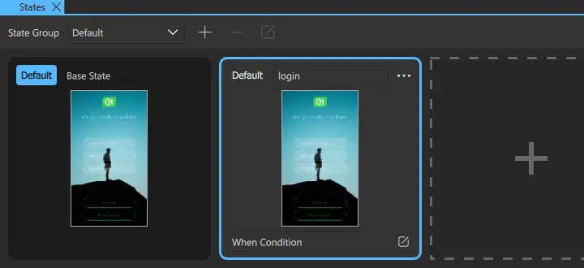
- Select repeatPassword in Navigator to display its properties in Properties.
- In the Visibility section, clear the Visible checkbox to hide the Repeat Password field in the login state.
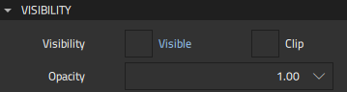
- In States, select Default for login to determine that the login state is applied when the application starts.
- With the base state selected, add another state and name it createAccount. This state should now look identical to the base state.
- Select the createAccount button in Navigator to display its properties in Properties.
- In Visibility, clear the Visible checkbox to hide the Create Account button in the account creation state.
- Select File > Save or select Ctrl+S to save your changes.
You can now see all the states in the States view:
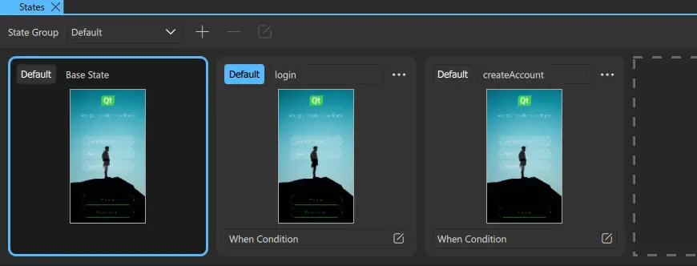
Live Preview displays the default state, login:
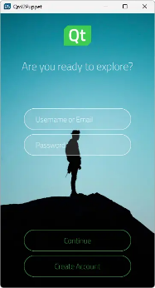
Next, create connections to specify that clicking the Create Account button on the login page triggers a transition to the account creation page.

Connecting buttons to states
Components have predefined signals that are emitted when users interact with the UI. The PushButton component contains a Mouse Area component that has a clicked signal. The signal is emitted whenever the mouse is clicked within the area.
Use the Connections view to connect the clicked signal of the createAccount button to createAccount state:
- Select View > Views > Connections to open the Connections view.
- Select createAccount in Navigator.
- In the Connections tab, select the button to open the connection setup options.
- Set Signal to clicked, Action to Change State, State Group to rectangle, and State to createAccount in the respective drop-down menus.
- Select the button to close the connection setup options.
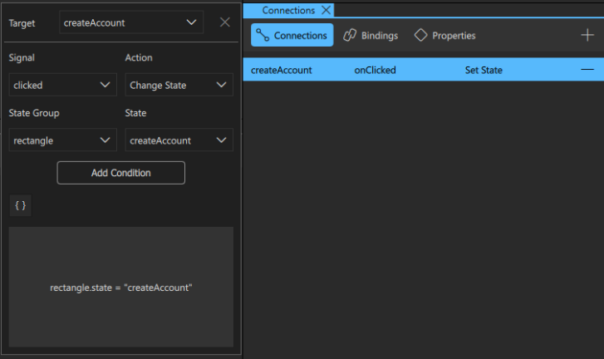
- Select File > Save or select Ctrl+S to save your changes.
Note: Alternatively, right-click the createAccount button in Navigator. Then select Connections > Add new Connection > clicked > Change State to createAccount.
In Live Preview, you can now select the Create Account button to go to the account creation page.


Next steps
To learn how to use a timeline to animate the transition between the login and account creation pages, see the next tutorial in the series, Login UI: Timeline.

4 Login UI: TimeLine
Illustrates how to use the timeline and states to animate UI components.
Login UI: Timeline is the fourth of the Qt Design Studio Login UI tutorials, which build on each other to illustrate how to create a simple UI with some basic UI components, such as pages, buttons, and entry fields.
This tutorial describes how to use the timeline and states to animate UI components. The result of this final tutorial is a UI similar to the preceding animation, where you can navigate to the account creation page by selecting the Create Account button.
In Login UI: States, you learned how to use states to simulate page changes in a UI and connections to provide user interaction with it. In this part, you learn another way of animating the UI by creating timeline animations that you bind to states.
The starting point for this tutorial is the completed Login UI: States project. You can download the project here.
Additionally, you can download the completed project of this tutorial here.
For more information, see Creating timeline animations.

Animating UI Components
In Login UI : State, you changed the visibility property in different states to simulate changing pages. To make sure that those changes won't interfere with the changes to the opacity property you make next, you first remove the states.
Then, add a timeline and insert keyframes for the opacity property to hide the Repeat Password field on the login page and the Create Account button on the account creation page. Because we want the Repeat Password field to appear to slide down from the Password field, you need to insert a keyframe for its anchor margin property. To be able to animate the anchor, you also need to pull out the fields from the column component and anchor them to the rectangle and to each other instead.
To preview the changes that you make, select the Live Preview button or select Alt+P.

Replacing columns with anchors
First, prepare the Screen01 component for adding animation:
- Double-click Screen01.ui.qml in Projects to open it in the 2D view.
- In the States view, select login > > Delete to remove the state. Repeat for the createAccount state.
- Select username in Navigator, and then select:
  - <- to move username into the parent rectangle.
  - -> to move username below tagLine in Navigator to preserve the component hierarchy.
- Repeat the previous step for password and repeatPassword.
- Select fields in Navigator, and then select Delete to delete it.
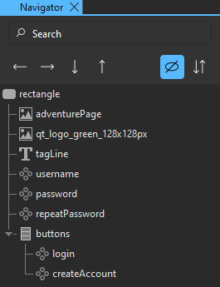
- Select username in Navigator.
- In Properties > Layout, set:
- Anchors to and .
- Target to tagLine to anchor username to the tag line.
- Margin to 170 and select to anchor username to the bottom of the target.
Note: Selecting the anchor button should automatically update the 2D view. If it doesn't, select on the 2D view toolbar to refresh the 2D view.
This attaches username to the bottom of the tag line while keeping its horizontal center aligned with that of the rectangle.
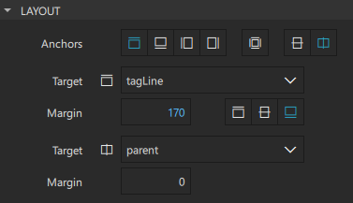

- Select password in Navigator.
- In Properties > Layout, set:
- Anchors to and .
- Target to username to anchor password to username.
- Margin to 20 and select to anchor password to the bottom of the target.
This attaches password to the bottom of username while keeping its horizontal center aligned with that of the rectangle.
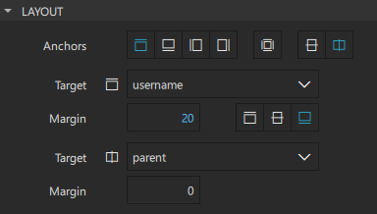
- Repeat the previous step to anchor the top of repeatPassword to the bottom of password with a margin of 20 and to anchor it horizontally to its parent.
- Select File > Save or select Ctrl+S to save your changes.
Screen01 should not display visible changes in the 2D view:
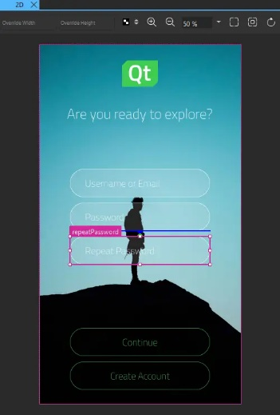

Adding a timeline
You are now ready to add the timeline.
To add a timeline with settings for running the animation:
- Select View > Views > Timeline to open the Timeline view.
- In Timeline, select to add a 1000-frame timeline and define settings for running the animation.
- In the Animation ID field, enter toCreateAccountState.
- Clear the Running in base state checkbox because you want the animation to run only after the user selects the Create Account button. Use the default settings for the other fields.
- Select Close in the Timeline Settings view to save the timeline and the animation settings.
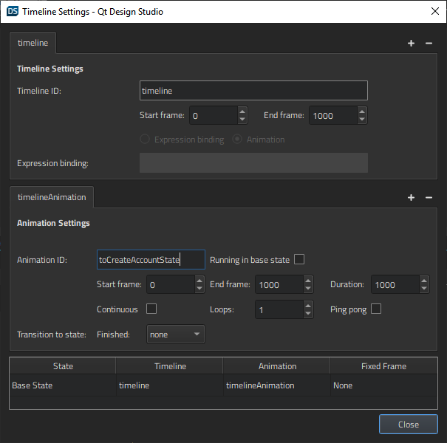
Next, record the animation in Timeline.

Inserting keyframes
To insert keyframes and record property changes in Timeline:
- Select repeatPassword in Navigator to display its properties in Properties.
- In Visibility > Opacity, select > Insert Keyframe to insert a keyframe for the opacity property of the component.
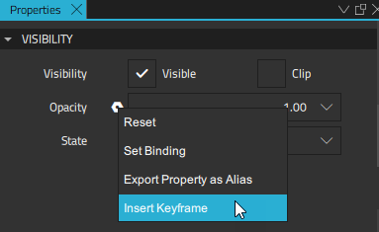
- In Timeline, check that the playhead is in frame 0, select the small arrow next to repeatPassword keyframe to expand it, and then select the (Per Property Recording) button for the opacity property of repeatPassword to start recording property changes.
- In Visibility > Opacity, enter 0 to hide the button, and press Enter to save the value.
- Move the playhead to frame 1000 and change the opacity value to 1 to show the button.
Alternatively, you can fine-tune the value of a keyframe by right-clicking the keyframe marker , and selecting Edit Keyframe.
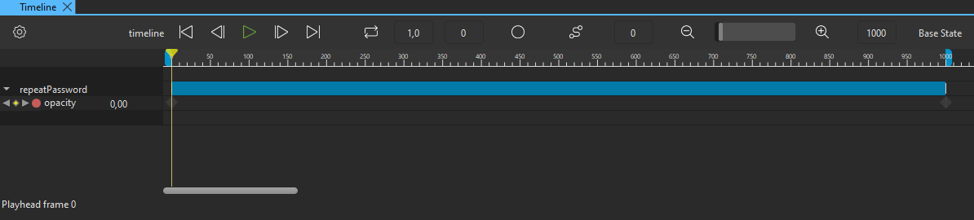
- Select the record button again to stop recording property changes. If you forget this, all the following changes are recorded, which leads to unpredictable results.
- Select createAccount in Navigator, and repeat the above steps to insert a keyframe for the Opacity property of the button and to record changes for it. However, this time the opacity value needs to be 1 in frame 0 and 0 in frame 1000.
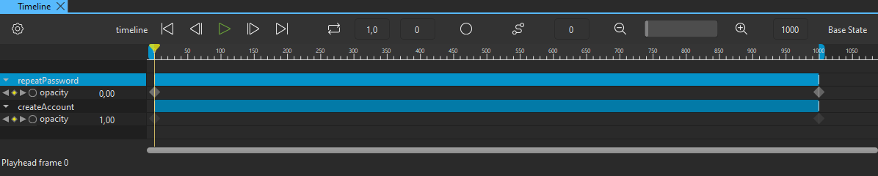
- Select File > Save or select Ctrl+S to save your changes.
When you move the playhead along the timeline, you can see how the Create Account button fades out while the Repeat Password field fades in.
Next, animate the top anchor margin of the Repeat Password field to make it appear to slide down from the Password field.

Animating anchors
To animate the top anchor margin of the Repeat Password field:
- Select repeatPassword in Navigator to display its properties in Properties.
- In Layout > Margin (under ), select > Insert Keyframe to insert a keyframe for the top anchor margin of repeatPassword.
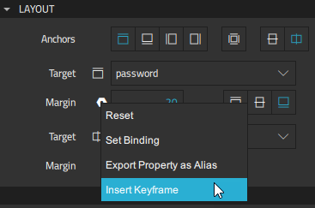
- In Timeline, check that the playhead is in frame 0, and select the record button for the anchors.topMargin property of repeatPassword.
- In Layout > Margin (under ), set a negative value for the top anchor margin, -100, to place repeatPassword on top of password.
- Move the playhead to frame 1000 and change the top anchor margin to 20, so that, combined with the change in the Opacity value, repeatPassword appears to slide down and settle below password.
- Select the record button again to stop recording property changes.
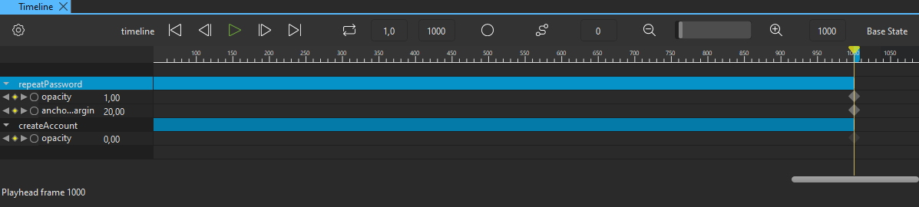
- Select File > Save or select Ctrl+S to save your changes.
Next, add easing curves to the anchor margin animation.

Adding easing curves
To make the transition seem smoother, add an easing curve to the anchor margin animation:
- Select the keyframe marker for the anchors.topMargin property at frame 1000 on the timeline to select it.
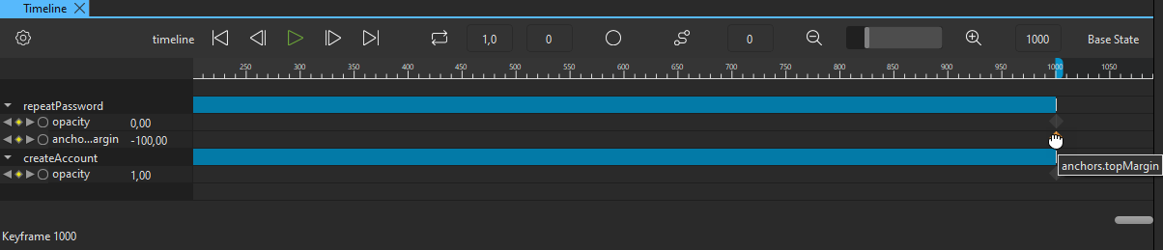
- Right-click the keyframe marker to open a context menu, and select Edit Easing Curve to add an easing curve to the animation.
- In Easing Curve Editor, select easeOutSine.
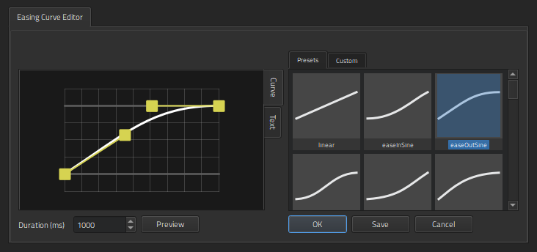
- Select OK to close the editor.
When you attach easing curves to keyframes, the shape of the keyframe marker changes from to .
Your timeline should now look something like this: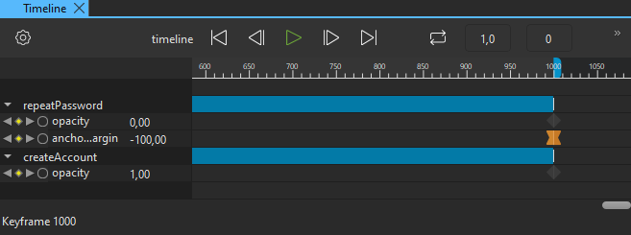
Next, create states for the login and account creation pages and bind them to the animation settings.

Binding animation to states
To bring back the states in the States view and bind them to the animation settings in Timeline:
- In States, select twice to add two states and name them login and createAccount. You don't need to make any property changes this time because you'll bind the states to property animations.
- In States, select Default for login to determine that the login state is applied when the application starts.
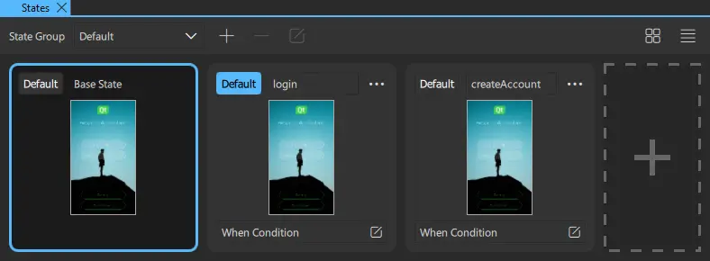
- With the base state selected, select Timeline > (Timeline Settings (S)) on the toolbar (or select S) to open the Timeline Settings dialog.
- Double-click the cell in the Timeline column on the login row, and select timeline in the list.
- Double-click the cell in the Timeline column on the createAccount row, and select timeline in the list.
- Double-click the cell in the Animation column on the createAccount row, and select toCreateAccountState.
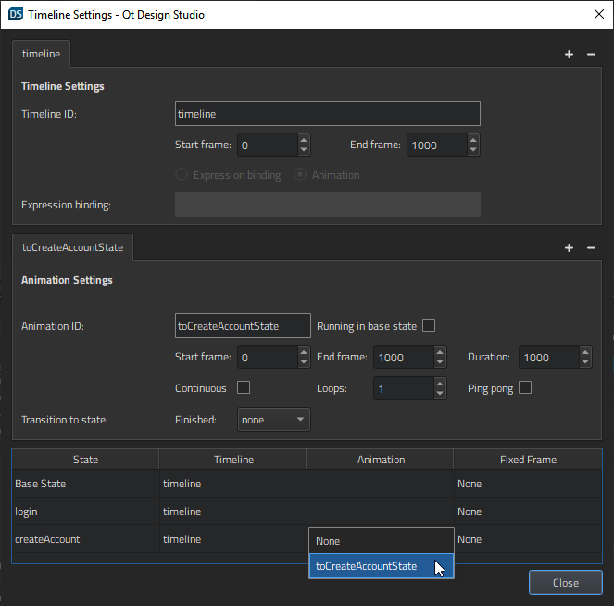
- Select Close to save the timeline settings.
- Select File > Save or Ctrl+S to save your changes.
In Live Preview, you can now select the Create Account button to go to the account creation page.

